CURRICULUM VITAE  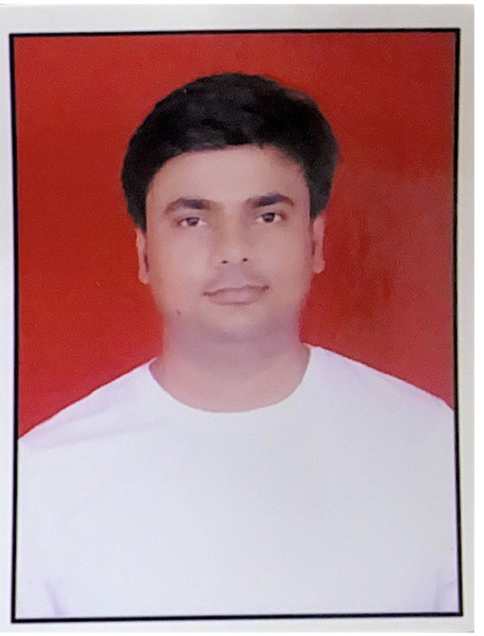  Lavlesh Mishra  Contact Information:  +91 9792874710  Address:  A-34 Jain Nagar Extension ,  Near Khatu Shyam Bazar ,  New Delhi,  New Delhi-110081  E-Mail:  Lavlesh0008@gmail.com  Personal Data:  Date of Birth : 05-02-1993  Father’s Name : Shesh Narayan Mishra  Sex : Male  Nationality : Indian  Marital Status : Married  Languages Known: Hindi,  English. | OBJECTIVE  My objective is to win all kind of challenge in my life and up grading knowledge skills from time to time and to work efficiently and effectively as well as grow with prestigious organization like yours. Thereby gain technical skills and experience essential for self-realization and accomplishment of my goals.  WORK EXPERIENCE  - Currently working in IWORLD from June 2018 as Sales Executive (Apple Premium Reseller)  - 2 Years as a Sales Executive in VIJAY SALES  - 1 years as a Promoter in V5 GLOBAL  ACADEMIC QUALIFICATION  - B.A. from SHIATS (8.36) CGPA  - Intermediate from U.P. Board (61.8%)  - Matriculation from U.P. Board (60%)  COMPUTER SKILLS  COMPUTER KNOWLEDGE : MS-Office (Word, Excel,  Power Point, Internet  JOB PROFILE : Sales and Team Handling  COMPETENCIES  - Fast learner.  - Adapt well to changes and pressures in workplace.  - Good presentation skills.  - Work effectively with diverse groups of people.  - Friendly with an upbeat attitude.  - Ambitious and committed to excellence.  - Able to relocate anywhere.  - Committed to deadlines and schedules.
DECLARATION

I hereby declare that all the above given factors are true and correct to the best of my knowledge.

Place: Delhi.

Date:……………

(Lavlesh Mishra )

