**CURRICULAM VITAE**

**SALIM AHMED**

**H. NO. – 169, NEAR SAI DHAM MANDIR, VILLAGE- AGWANPUR**

**SECTOR-91, FARIDABAD, HARYANA- 121013**

**CONTACT NO.** – **8802065293**

**AADHAAR NO. – 971678462656**

**EMAIL: -** [**salimahmed0999@gmail.com**](mailto:salimahmed0999@gmail.com)

Objective:-

To enhance my skills at such a work places where hard work punctuality and hard working is recognized as master key to success. Learning from experience of others and thereby provide to be an asset for organization where I work.

Educational Qualifications:-

|  |  |  |  |  |  |  |  |
| --- | --- | --- | --- | --- | --- | --- | --- |
| **S.NO.** | **EXAM PASSED** | **NAME OF THE BOARD** | **NAME OF SCHOOL/COLLEGE** | **SUBJECT** | **YEAR OF PASSING** | **%** | **DIVISION** |
| 1. | 10th | CBSE | DPS MATHURA ROAD | ALL | 2011 | 66 | FIRST |
| 2. | 12th | CBSE | DPS MATHURA ROAD | COMMERCE | 2013 | 73.1 | FIRST |
| 3. | Graduation (BBA) | IP UNIVERSITY | NEW DELHI INSTITUTE OF MANAGEMENT |  | 2016 | 66 | FIRST |

Experience:-

**Company: -** Concentrix Daksh Service India Pvt. Ltd.

**Process: -** Reliance JIO

**Duration: -** 28 September 2016 To 9 February 2019

**Designation: -** Representative Operations

**Key Accomplishments:-**

* Handling customers of Inbound prepaid customers of JIO.
* Outbound calls to Railway Corporate Plans Customer.
* Solve the customer’s queries and educate them about the same.
* 3 Consecutive CAT 100 Score in Audits.

Personal Details:-

Father’s Name : Mr. Nasir Ahmad

Date of Birth : 22nd November 1994

Marital Status : Unmarried

Gender : Male

Nationality : Indian

Language : Hindi & English

Hobbies : Music, Movies, Surfing net

Declaration

I hereby declare that all information given by me is true and I am solely responsible for its authenticity.

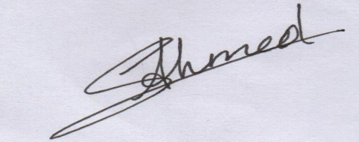

Date: - 17/06/2020

Place: - FARIDABAD **SALIM AHMED**