CURRICULUM VITAE

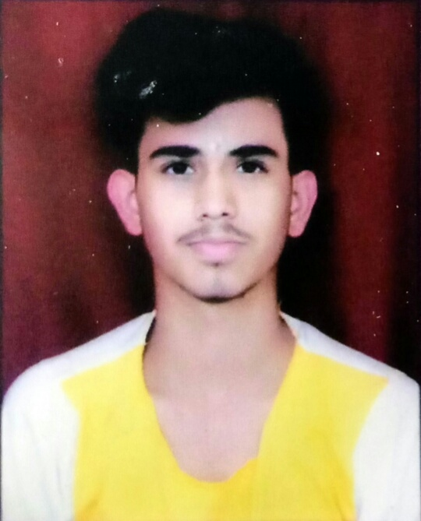
Owais Siddiqui

H. No. 3/738, Ruchi Khand 1st,
Sharda Nagar, Lucknow (226012)
(U.P.) INDIA
Contact No.: +91 9918260517
Email: owaissiddiquek9@gmail.com

Objective:

To blend all my qualification, abilities and energy in to perform my duties successfully and innovatively and my organization & reach the top in my profession.

Professional Skills:

- Problem-Solving Skills
- Detail-Oriented
- Time-Management Skills
- Communication Skills

Educational Qualifications:

- High School Completed from ICSE Board in Year 2020 With 1st Division.

- Intermediate Completed from ISC Board in Year 2022 With 1st Division
Professional Qualifications:

- Completed Data Entry Operator Course From NSDC (SkillsTrainer).

- Completed English Speaking Course From NSDC (SkillsTrainer).

Experience

- Six Month experience in Mcdonald as a Cashier

- One Year experience in Reliance Digital as a Digital Expert

- One Year experience in SONY as a Shop Floor Associate

- Currently Working in Panasonic as a FIS

Personal Profile:

- Father’s Name : Late. Javed Siddiqui
- Father’s Occupation : Service Technician
- Date of Birth : 1st of November 2003
- Gender : Male
- Marital Status : Unmarried
- Nationality : Indian
- Language Known : Hindi, English

Declaration:

I confirm that the information provided by me is to the best of my knowledge & belief.

Place :
Date : (Signature)

