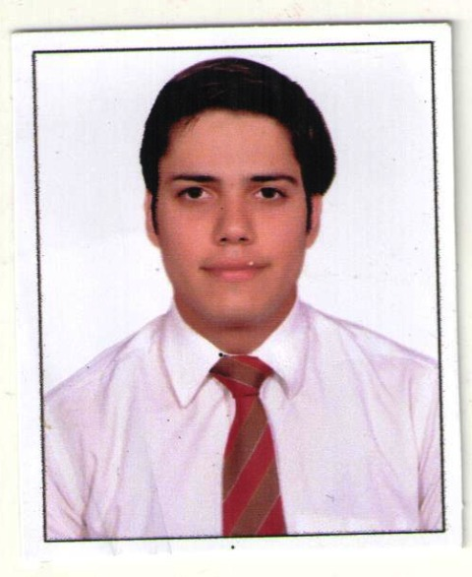
MUKUL KANDHARI
Flat No-200, Pocket-7, Sector-2, Rohini,
Delhi - 110085
Contact No: 9953101735
Email Address: - mukulkandhari1@gmail.com
CAREER OBJECTIVE:

To be part of an organization in which I can offer my services with utmost sincerity and if given a chance I shall do/ discharge all jobs directed toward improving the prospects of the company by applying my skills, experience as well.

EXPOSURE:-
- Exposure to MS Office (Word, PowerPoint, Excel) Internet
- Good organizational, analytical problem-solving skills & ability to do multitask

- Good customer service skills with a polite and professional approach

- Ability to deal tactfully with upset or angry customer/passenger

- Good leadership & teamwork skills

- Ability to backend work

[Personality Traits:-

- Excellent interpersonal and communication skills

- Good team player as well as ability to work individually

- Positive thinking, honest and hardworking

- Excellence in creating, applying new ideas and skills

- Strong logical, analytical and problem-solving skills

Work Experience:

Have been associated with Hammerhead Global Solutions Pvt Ltd from 01st June 2021 to 1st April 2022. The designation was Dispatcher.

Work Responsibilities:
Making Daily Activity Reports and Maintaining Records
Making an Incident and Sent to the Management and Client

Coordinate with on-site guard and make a record for every hour.

Maintain timesheets daily for Security Officers.

Handling all US calls and solving the queries.

WORK EXPERIENCE:
Have been associated with Beyond Outsourcing Pvt Ltd from 19th August 2019 to 31st May 2021. The current designation was Virtual Field Supervisor.

Work Responsibilities:
- Making Daily Activity Reports and Maintaining Records
- Making an Incident and Sent to the Management and Client

- Coordinate with on-site guard and make a record for every hour.

- Maintain timesheets daily for Security Officers.

- Handling all US calls and solving the queries.

WORK EXPERIENCE:
Have been associated with BWFS since 1st Oct13. The designation was Team Leader from 1st Sep15 to 28 Feb 2019.
- Joined as a Customer Service Host on 1st Oct1tn 1st June 2013
- Responsible for the safety and comfort of passengers
- Doing routine safety checks before takeoff
Work Responsibilities:
- Welcoming Passengers as they come to the counters and help them. Attending pre-flight briefings
- Helping passengers load luggage
- Dealing with high-net-worth individuals in a professional and mature manner
- Circulating customs and immigration documents for passengers
- Solve operational problems regarding aviation management
- Inspect procedures and maintain standard operating procedures to ensure aviation standards are met every time.

PROFESSIONAL QUALIFICATION:
- Training on Dangerous goods (DGR)
- Training on Aviation Security (AVSEC)
EDUCATIONAL DETAILS:
10th from CBSE Board
10+2 from CBSE Board
Bachelors in Commerce

STRENGTH:-
- Positive attitude good analytical and problem-solving abilities. Disciplined Punctual and hardworking.
PERSONAL INFORMATION:

D.O.B. : 15-09-1993

Religion. : Hindu

Marital Status. : Married

Nationality. : Indian

Strength. : Confidence Level, Sincerity, Hard

Sex : Male

Languages. : Hindi, English and Punjabi

Declaration (I hereby declare that all information is correct competent with any knowledge and belief).

Date:

Place: New Delhi MUKUL KANDHARI

