Mohammad Sameer
Email: ska.malik1303@gmail.com
Phone: +91-9555886606

Service In charge and Senior Apple Service Technician
14+ years of experience; Qualification- B.COM,
Apple Certified Macintosh Technician (ACMT)
Cisco Certified Network Associate (CCNA)

IT
I want to be part of an environment that promotes team efforts and provide opportunity for values based growth as well as career advancement while making a significant contribution to the employer’s organization.

Work Experience
Company |  | Location | From | To | Designation
resQ by Reliance Retial Limited  AVTECH DIGITAL EQUIPMENTS PVT. LTD. |  | Delhi, India  Delhi, India | Nov ‘11  Sep ‘09 | Oct ‘23  Sep ‘11 | Senior Apple Service  Technician  Apple Service Technician
Nirmal Computer Solution |  | Delhi, India | April ‘06 | Aug ‘09 | System Engineer
Educational Qualification
ACMT (Apple Certified Macintosh Technician)  CCNA (Cisco Certified Network Associate) with 93.7%.  Diploma from Jetking in Computer Hardware and Networking  Graduation: Delhi University with B.COM Pass  Schooling: Govt. Boys Senior Sec. School, Delhi  - CBSE Passed 10+2  - CBSE Passed 10th |  |  |  |  |  | 2013  2007  2000-2004  2005  2000
Experience Details
Nov ‘11 – Till Present Delhi  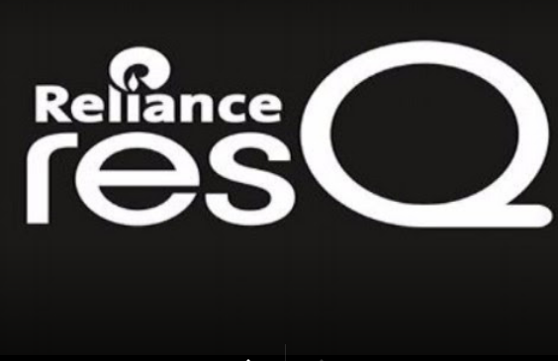  resQ By Reliance Retail Limited | Role: Service Incharge  - Handling Complete Service Activities like Repair Creation, Repair Closing, Maintain ACSE Score and CSAT etc.  - Handling All Hardware and software issues of Mac Machines & iPhones.  - Involved in Installation of MAC OS and related Software  - Handling client complaints online\onsite related to all kinds of hardware like IMac, MacBook, MacPro, G4, G5 and knowledge of GSX  - Involved in troubleshooting of IPods  - Managing customer data.  - Involved in customer satisfaction activities through regular follow ups
Sep ’09 – Oct ‘11 Delhi   (www.avtechdigital.com)  Sep ’09 – Till Date Delhi  Company: NIRMAL Computer Solution | Role: Apple System Engineer  - Handling all Hardware and Software issues of Mac Machines.  - Involved in Installation of MAC OS and related Softwares  - Complete knowledge of configuring Network, Mail Setup, Printer and Scanners in MAC OS  - Involved in troubleshooting of iOS Devices.  Role: System Engineer  - Troubleshooting Operating System (95,98,2000,NT,XP)  - Assembling – Re-assembling computers  - Handling client complaints (Online\Onsite)

Key Skills
Achievements
- Achieved Premium Service Provider Goal of Noida Location 2017-2018.
- Achieved Premium Service Provider Goal of Kirti Nagar Delhi Location 2018-2019

Professional Management Skills
- Problem Solver and Meeting Objectives
- Quick and apt Decision Making Capacity and good Analytical Skills
- Remarkable ability to assist customers with resolution of product questions and problems
- Strong and comprehensive understanding of multi-product & even solution selling
Other Skills
- Well-developed and effective communication skills and customer persuasion
- Exceptional energy, dynamic personality with a sense of urgency

Hobbies & Interests
- Enjoy listening to Music and hanging out with friends.

Personal Details
- Date of Birth: 20th Sep 1983 | - Sex: Male
- Nationality: Indian | - Marital Status: Married.
- Address: A 6/71, Paschim Vihar, New Delhi- 110063.
- Phone: +91-9555686606 | - Email: skamalik1303@gmail.com

