CURRICULUM VITAE
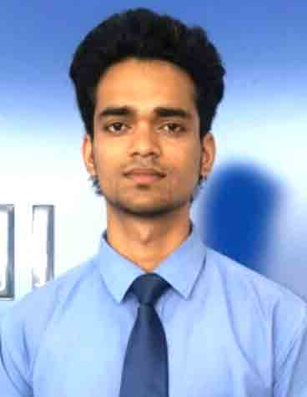
ABHISHEK KUMAR SINGH
Contact: 7459955511
Email: abhi.veer003@gmail.com

CAREER OBJECTIVE
To do something in innovate in which i can use my knowledge for the growth of company.

EDUCATIONAL QUALIFICATIONS:

Board/University | Degree(s) obtained | Year | Division
Purvanchal University | B.Sc. (PCM) | 2017 | 50.00%
U.P Board | 12th | 2012 | 66.00%
CBSE Board | 10th | 2009 | 48.00 %

WORK EXPERIENCE

- 6 Months experience in JSV Hyundai as a Sales Executive in August 2017 to January 2018 ( LUCKNOW )
- 12 Months experience in Times Pro Consulting LLP as a Senior Sales Executive in March 2018 to February 2019 ( GURUGRAM )
- 2 Year Experience in A&P Micro Finance Associates as a Branch Manager in june 2019 to May 2021 ( LUCKNOW )
LANGUAGE PROFICIENCY

Language | Reading | Speaking | Writing
English | Excellent | Fine | Fine
Hindi | Excellent | Excellent | Excellent

HOBBIES

Playing Cricket, Listening Music, Reading Books & Novels

PERSONAL DETAILS
- Full Name : Abhishek Kumar Singh
- Mother’s Name : Mrs. Bina Singh
- Father’s Name : Mr. Awadh Nath Singh
- Date Of Birth : 05/12/1994
- Civil Status : Unmarried
- Nationality : Indian
- Languages Known : Hindi & English

CONTACT DETAILS
Address: RAGHUNATH NAGAR COLONY KHARGAPUR GOMTI NAGAR LUCKNOW 226010.

CERTIFICATION

I, the undersigned, certify that to the best of my knowledge and belief, this information sheet correctly describes me, my qualifications, and my experience. I would be glad to provide any other information required.

Place: LUCKNOW SIGNATURE

Abhishek K. Singh

