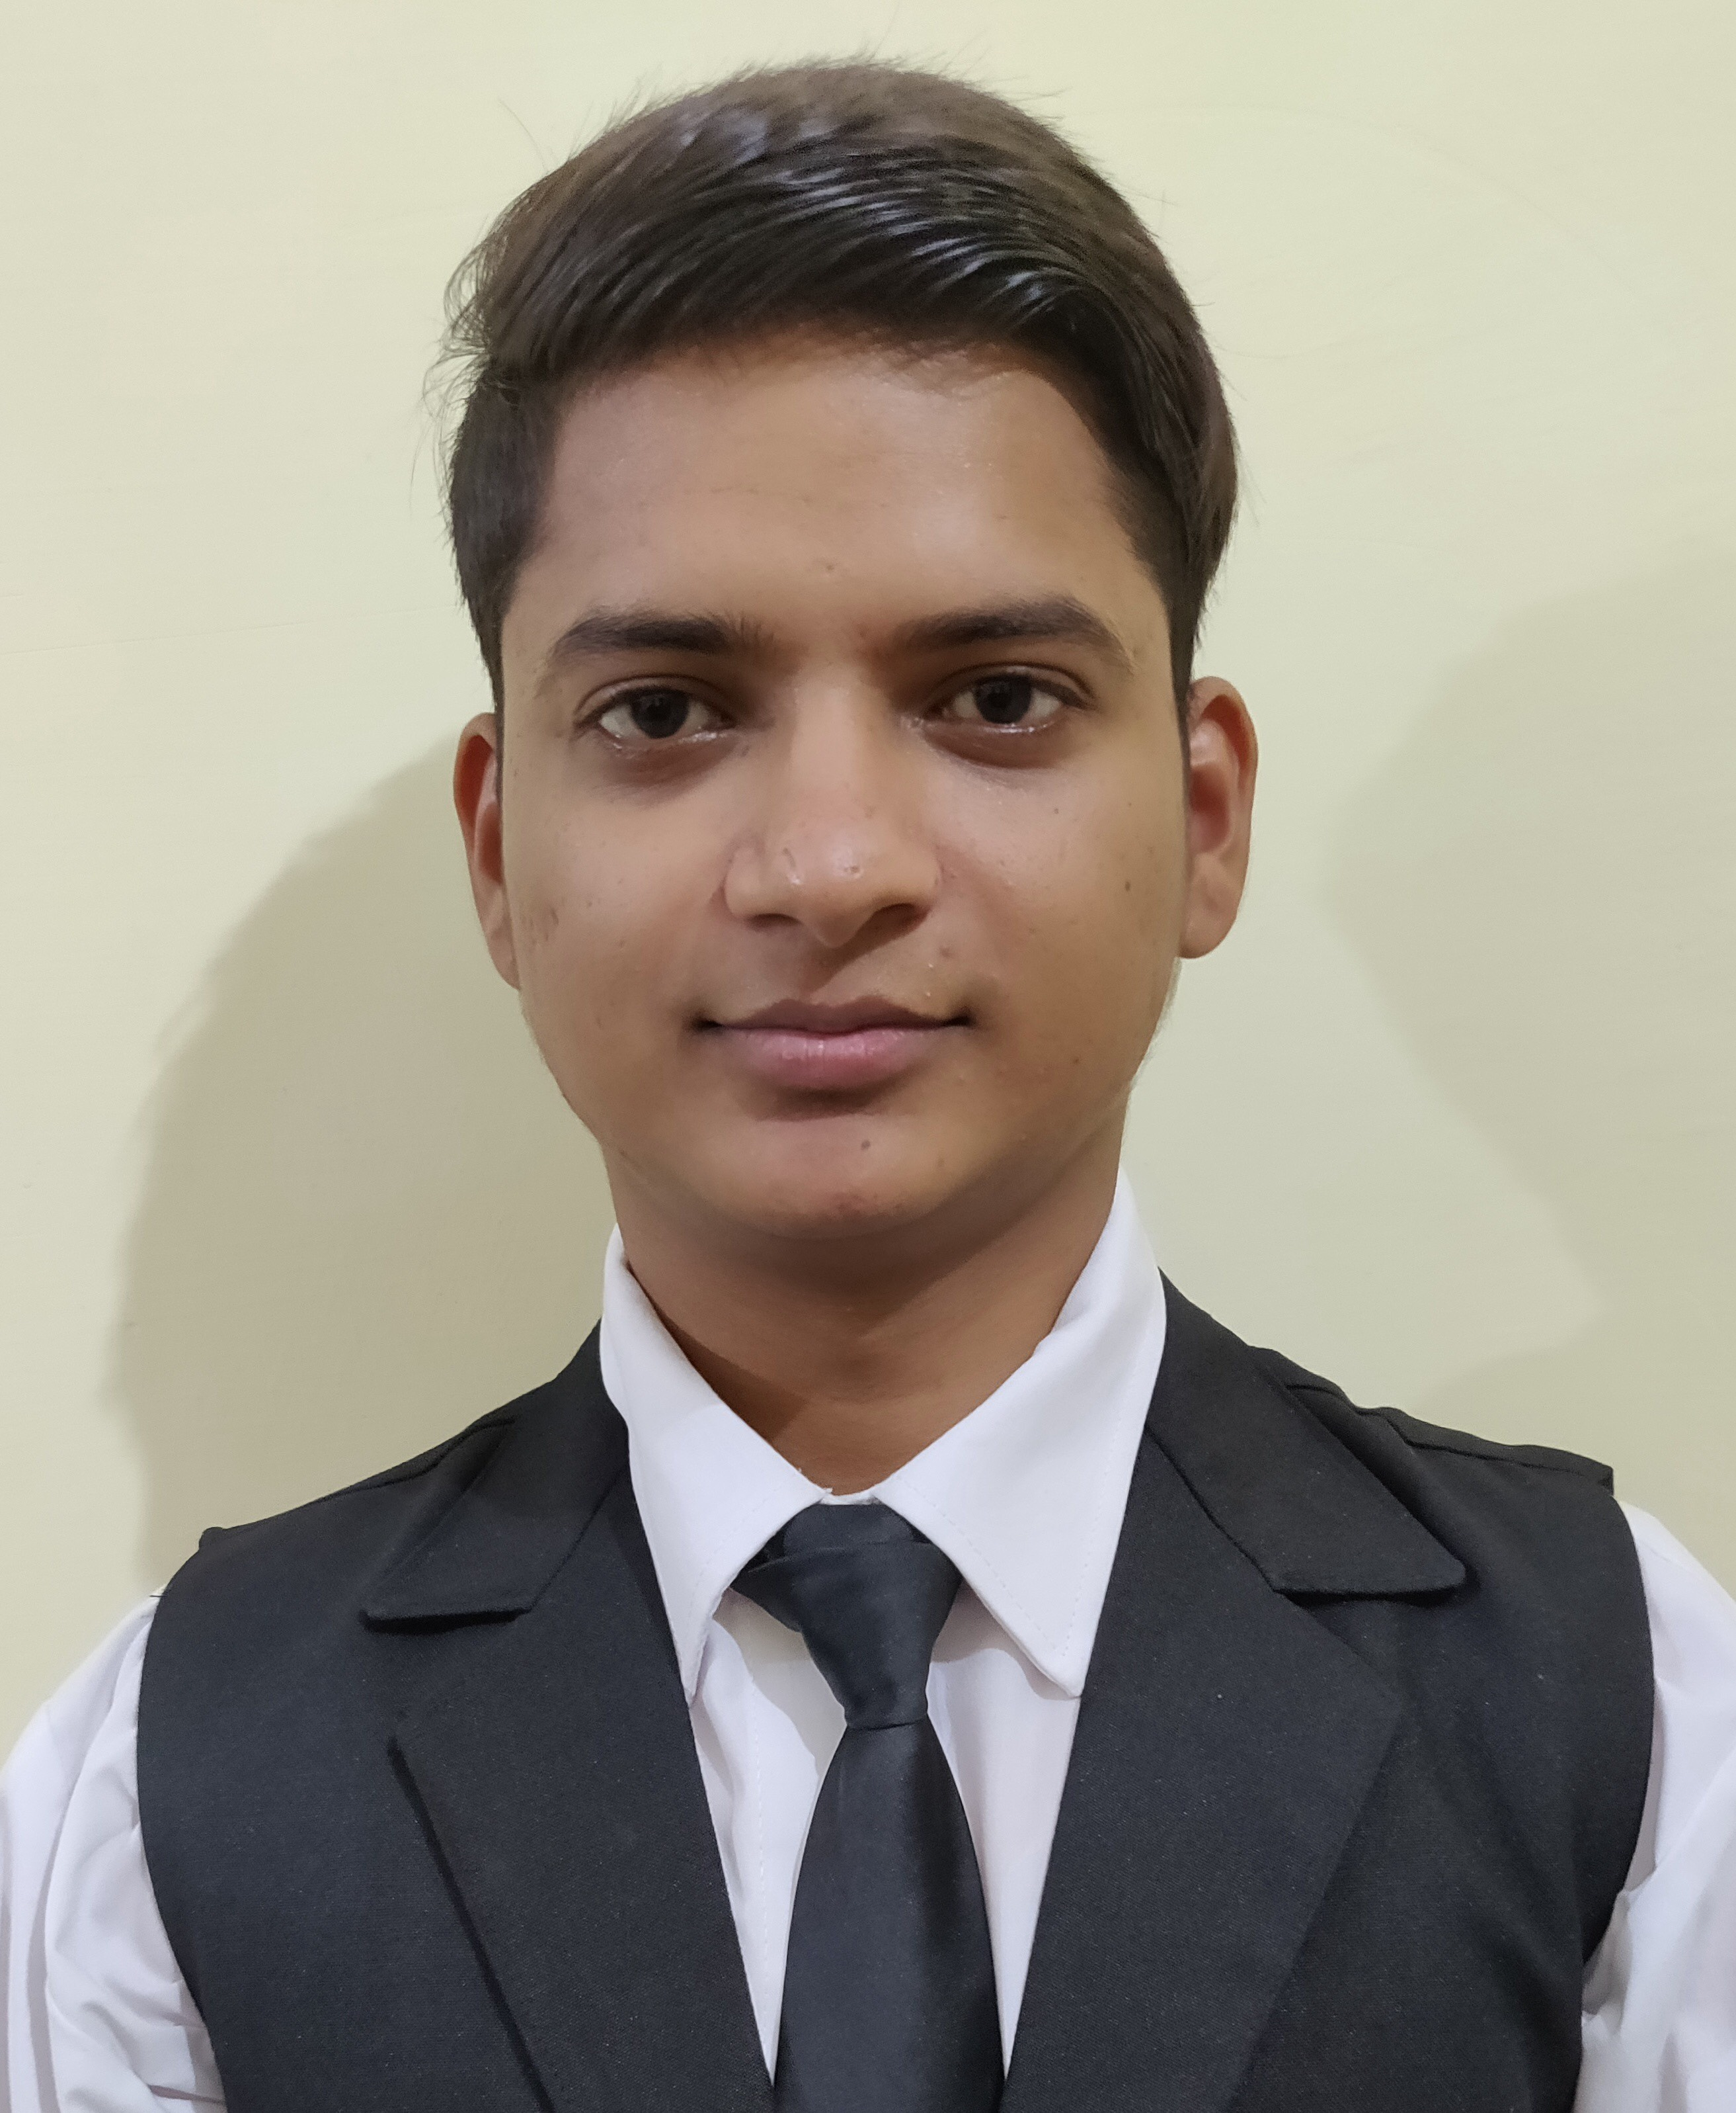
CURRICULUM VITAE

Ravi Kushwah
Male, Indian, 23 years
Phone : +91- 9812516214
E-mail : ravirajput3213@gmail.com
Address: CB 188 Ring Road,Naraina 110028
Career Objective:

To seek challenging assignment and responsibility, with an opportunity for growth and career advancement as successful achievements.

Professional Qualification:
Year | Qualification | Institution | University | Result
2016-19 | Bachelor In Hotel Management | I.H.M Kurukshetra | NCHMCT | Pass
Academic Qualification:

Year | Qualification | Institution | University/Board | Result
2015 | High Secondary 12th | Suraj Senior Secondary School | CBSE | Pass
2013 | Matriculate | Raman Munjal Vidya Mandir | CBSE | Pass
Industrial Training:
Worked as a trainee in all major departments at SHANGRI-LA EROS, NEW DELHI for 17 weeks.

Work Experience:
2 years experience of working and shift handling on position of 2nd assistant manager.

Achievements:
- Certified in Shift Management Excellence
- Certified in Food Handling
- Certified in Advance Shift Management
- Certified in Effective Management Practice

Key Skills & Attributes
- Good communication & decision making ability.
- Teamwork & interpersonal skills.
- Ability to work under pressure.
- Having pleasant personality that allows better interaction with the clients.

Personal Details:

Date of Birth : 18th November,1997
Father’s Name : Mr. Om Parkash
Marital Status : Unmarried
Hobbies : Interacting with people, Travelling.
Languages Known : English, Hindi.

(Ravi Kushwah)

