**CURRICULUM VITAE** 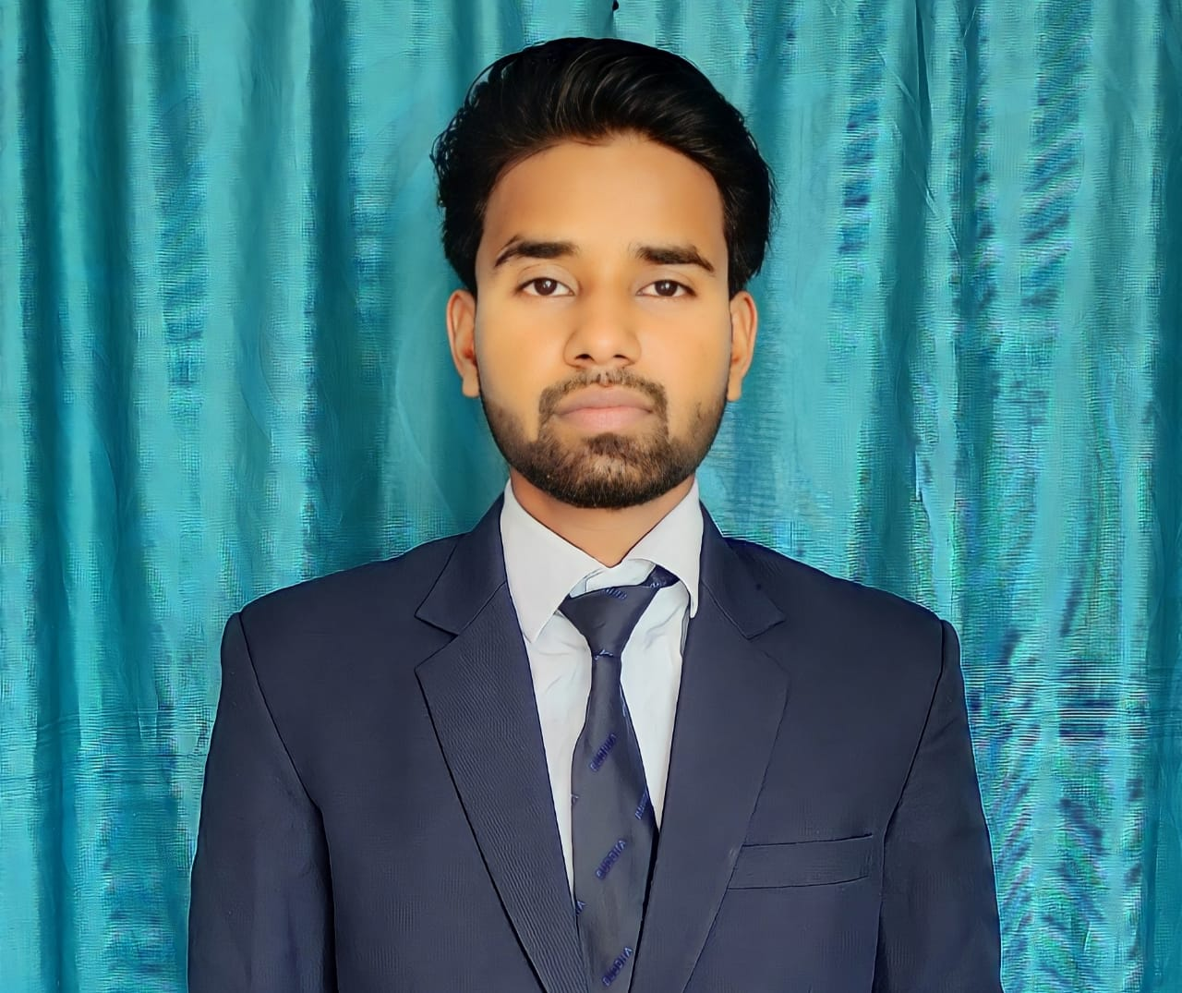

**VIVEK GUPTA**

**Permanent Address:** Barwa Meer Chhapar , Post - Desahi Deoria, Dist - Deoria, Deoria (up) - 274206

Email ID- vtanya9801@gmail.com

Contact: +91 8957676640, 9918252594

|  |
| --- |
|  |

**Career** **Objectives*:***

To work with full dedication and integrity to achieve the goal for development of organization and self and the team.

**TechnicalQualification*:***

**Diploma** in **Civil Engineering** from Buddha Institute of Technology, Gorakhpur affiliated to Board of Technical Education, Lucknow.

**Academic Qualification:**

|  |  |  |  |  |
| --- | --- | --- | --- | --- |
| **Examination** | **Board/University** | **School/College** | **Year of Passing** | **Percentage** |
| **B.Tech**  **(Civil)** | AKTU , Lucknow | Buddha Institute of Technology, (Gorakhpur) | 2024  Pursuing | 3th  Sem 79.21% |
| **Diploma**  **(Civil)** | Board of Technological Education , Lucknow | Buddha Institute of Technology, (Gorakhpur) | 2021 | 70.38% |
| **Secondary school** | UP Board Allahabad | L.B.S.S.N Pipra Madan Gopal, Deoria | 2018 | 69.65% |
| **Higher secondary school** | UP Board Allahabad | S.T.P.R.G. Inter college Desahi Deoria, Deoria | 2017 | 84.76% |

**TECHNICAL SKILLS**

**. AUTO CAD 2D**

**ABILITY**

**. MS Word**

**. MS Excel**

**. Structural engineer**

**. Concrete**

**. Management**

**. Team Work**

**. Supervision**

**. Ability to work under pressure**

**. Good communication**

**EXPERIENCES**:

* **1 year 6 Month ,**
* **Current Job- Bhawan Nirman Solution Pvt Ltd.**

**PREVIOUS EMPLOYER INTERNSHIP**

**Organization Name : Ambuja Cement, Gorakhpur** (U.P.)

**Designation : Lab Technician**

**Period :** From june 2021 to December 2021.

**Company Profile : Cement Testing**

**ACADEMIC PROJECT WORK:**

**Model Presentation** : **Brick Masonry With Cement, Sand & Rice Husk Ask**

* 1st Winner

**Strengths**:

* Ability to stay Focused & motivated.
* Trustworthy & reliable.
* Innovative, intelligent, hard working.

**Profile*:***

Self motivated to achieve engineering and management objectives through share hard work and loyalty with clear understanding of coordinated efforts in a team work concept.

**Personal Details:**

* **Father’s Name :**  Mr. Subash Chandra Gupta
* **Date of Birth**  **:** 10/09/2002
* **Sex :** Male
* **Marital Status :** Unmarried
* **Language Known :** Hindi & English
* **Nationality :** INDIAN

**Declaration:**

I here declare that all the facts given above are true to the best of my knowledge and belief.

DATE*:*

PLACE*:* (VIVEK GUPTA)