Name: Narayan Singh

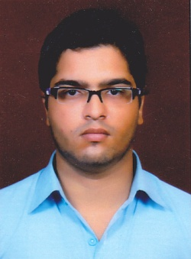

Phone: 8787208693, 9026565246

Email: narayansingh2592@gmail.com

Marketing professional with 1 year of experience result driven target oriented while providing excellent customer service to the Esteem Customer.

**Expertise:**

* Financial management of the customer
* Knowledge of financial products and services like SIP’s
* Ability to Build and manage a strong customer Base
* Good Communication skills
* Expertise in Marketing and selling financial products and services
* Relationship Management and customer service
* Ability to Build Interest and Confidence in clients.
* Relationship building and good market knowledge.

**Experience:**

* Current working as an Marketing Executive in Digital Marketing Robo.
* Worked as an Assistant Professor for one year in SR Group Of Institution.
* Working as an Sales Associates for 8 months ( June 2018 to Jan 2019) in Aditya Birla Group
* Good understanding of Marketing and sales of products and services

**Professional Experience:**

**Marketing Executive**

June 2018- Jan 2019

* Weekly meetings with sales team and take appropriate guidance and motivation to achieve target.
* Worked in Jhansi, Uttar Pradesh and was investments in SIP’s , Mutual Funds.
* Handled the relationship with IFA’S (Agent) and with few Bank’s like P.N.B, HDFC, IDBI, BOB etc.
* Had achieved the target of 100% SIP’s from BOB
* Had excellent interpersonal and communication skills which helped in problem solving, planning, organizing and scheduling and scheduling the various activities with a stipulated time frame.

**Assistant Professor – SR Group of Institution**

**(January 2019 to till date)**

* Monitoring and evaluating results as well as initiating steps to boast opportunities in the students
* Giving practical knowledge to students of Marketing Management

**Marketing Executive**

**(Jan 2020 till date)**

* Daily meeting with sales team.
* Take appropriate guidance and motivation to achieve target.
* Daily meeting with clients.
* Lead generation.
* Direct sales.

**Academia:**

* Master in Business Administration from AKTU in year 2018
* Bachelor in Commerce from Lucknow University, in year 2014
* Intermediate from Board of High School and Intermediate Education, U.P in year 2011
* High school from Board of High School and Intermediate Education U.P in year 2009

**Personal details:**

**Date of Birth-** 25-05-1994

**Language Known-** English, Hindi

**Interest-** Travelling and Music

**Permanent Address:** 551 Cha/ 275, New Sardari Khera, Alambagh, Lucknow

**Reference:** On request.