 | Mukesh Kumar Jha
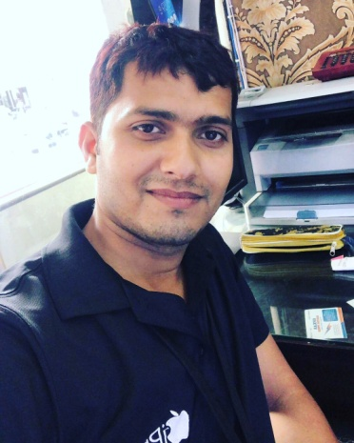 | House No. 1325, L BLOCK,  MANGOL PURI  NEW DELHI-110083  Phone No.: 8882838244  E-mail: mukeshjha680@hotmail.com

Objectives

To have a challenging career in a progressive, disciplined and organization to achieve synergy between professional competence and personal growth through creative challenge and goal driven performance.

Education

  - 10TH Passed from CBSE
  - 12TH Passed from NIOS
  - Graduation from Jodhpur National University.
  - MBA in Retail and Operation Management from Subharti University.

Experience

- Worked with TATA CROMA ENTERPRISES as a Sales executive from Sept, 2012 to Dec, 2014.
- Worked with MOBILITY WORLD as a Store manager from 01 January,2015 to 01 September,2016.
- Currently working in channel play as a apple I-Pro from October, 2016 to till Now.

ACHIEVMENTS

- Got an “APPLE APP KIT” from Apple.

Personal

- Date of Birth : 7th September , 1991
- Marital Status : Married
- Languages Known : Hindi, English and Maithili

I certify that all the information furnished above is true to the best of my knowledge and are correct testimonial to my qualification.

Mukesh Kumar Jha

Signature

