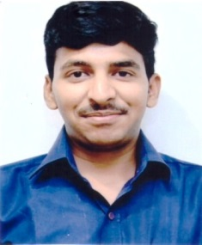**RESUME**

**RAHUL SINGH NEGI**

Address: B-505, 3rd Floor Dakshin Puri

Ambedkar Nagar DELHI – 110062

Mobile no. 8700133084

Email Id – [rahulnegi2603@gmail.com](mailto:rahulnegi2603@gmail.com)

_____________________________________________________________________________________

**EDUCATIONAL QUALIFICATION:-**

* 10th Class Passed From C.B.S.E. Board.
* 12th Class Passed From C.B.S.E Board.
* Graduate (Political Science Hon’s) from Delhi University
* Pursuing MA (HINDI) From IGNOU University

**OTHER SKILLS:**

Good Knowledge of Computer, Done MS-Office (MS-Word, Excel, PowerPoint)

**EXPERIENCE:**

Presently working at **Power Finance Corporation Ltd.** as an Office Assistant From 18.08.2014

On contract basis.

**Work Profile:**

Handling of all types calls, book an appointment and arrange, Official Meetings, Filing work, daily data and Dak entry for, Office record.

**PERSONAL DETAILS**:

Father’s Name : Sh. Sohan Singh Negi

Date of Birth : 26/03/1995

Nationality : Indian

Religion : Hindu

Language Known : Hindi & English

Marital Status : Unmarried

**Declaration:-**

**I Hereby Declare that all the information mentioned above are true to the best of my knowledge.**

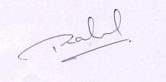Date: ____________

Place: Delhi

**(RAHUL SINGH NEGI)**