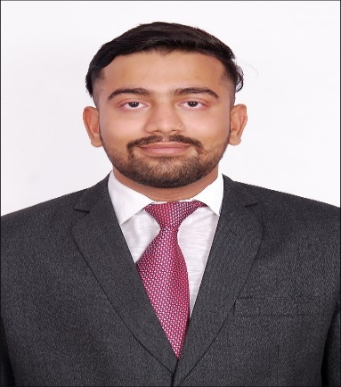  Date of Birth :  16th August 1998  CONTACT:   vishalballan@gmail.com  +91 8451070081  Address:  A/2006, Indraprasth, New Golden Nest, Bhayander (E), Thane - 401105  http://linkedin.com/in/vishal-ballan-b2790221a  KEY SKILLS:  Interpersonal skills  LANGUAGES:  - English  - Hindi  - Marwari  Hobbies/ interest  - Social Work  - Chess  - Table Tennis | VISHAL BALLAN  CAREER OBJECTIVE:  Seeking an opportunity in the field of marketing for developing thorough understanding about the sector and also being able to showcase my skills and contribution to the success of the company.  PROFILE SUMMARY:  - Highly motivated entry-level professional seeking an opportunity to utilise the knowledge of marketing domain.  - Committed to achieving employer’s objectives, skilled at creating marketing strategies and identifying client’s needs.  SUMMER INTERNSHIP PROGRAM: pgdm - Marketing (June 2021 – July 2021)  COMPANY’S NAME: NNEELL’S INVEST  - PROJECT TITLE: Brand Awareness & Marketing Campaign for a Company  ROLE AND IMPLEMENTATIONS:  - Conducting Marketing Research and Digital sales.  - Consolidation & Preparation of draft content and postures.  - Raising and resolving queries on basis of Stock market courses.  ACADEMIC CREDENTIALS:  Program Institute/University Year % / CGPA  PGDM Marketing Durgadevi Saraf Global Business School Pursuing 3.95 (First Year)  BMS Ghanshyamdas Saraf College of Arts & Commerce 2020 5.68  HSC Ram Ratna Vidya Mandir 2017 62.8%  SSC Seven Square Academy 2014 6.4  cERTIFICATIONS & PROJECTS:  - Certificate course in GST – Practice & Procedures  - Certificate of participation in SSR (Sahyog for Social Responsibility)  eXTRA CURRICULAR ACTIVITIES:  - Participated in cultural activities at school and college level.  - Done various projects in Rotract club like such as Beach Clean-up drive, Blood donation camp, health check-up camp, help to underprivileged child and old age homes.

