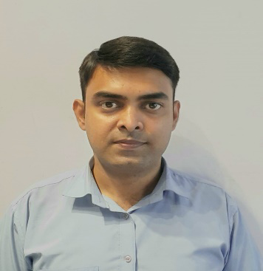**Gaurav Kumar**

**Team Leader**

**Mobile: +91 7838477730**

**Email: gauravchap@gmail.com**

**Add: -**99/2 D, Banwari Lal Gehlot,

Dabri More, New Delhi-45

**OBJECTIVES:**

To secure a challenging and responsible position with an organization that offers an excellent opportunity for professional advancement and seeking a position to utilize my skills and abilities in the industry that offers to help me to explore myself and professional growth while being resourceful, innovative and flexible.

**PROFESSIONAL & ACADEMIC CREDENTIALS:**

* Bachelor in science Math(h) with 69% Marks from Jai Prakash university, Bihar in 2012.
* Intermediate in PCM with 59% Marks from Bihar School Examination Board, Patna in 2009.
* Matriculation with 52% Marks from Bihar School Examination Board, Patna in 2007.
* Basic Knowledge of computer, MS office and Emailing.

**SKILLS:**

* Good interpersonal and presentation skills.
* Time management.
* Good ability to build relationships with customers.
* Good listening ability.

**WORK EXPERIENCE:**

* Currently work as a Team Leader in MG Mobiles India Pvt. Ltd. from 06th may 2022 to present.
* Last working as Business Development Associate in Think & Learn Private Limited (BYJUS)from 22th of March to 05th of May 2022.
  + Target oriented job.
  + Generating sales lead.
  + Build relationship with customer.
  + Direct Sales.
* Third job as a Store Manager in Manak Waste Management Pvt Ltd from Aug 2nd 2021 to Oct 18th 2021.
  + Hygiene
  + Build relationship with customer.
  + Procurement
  + Inventory management
  + Mobile Phones and accessories Sale Drive
  + Screen Pro Sale and service management.
* Second job as a Team Leader in MG Mobiles India Pvt Ltd from April 22nd 2016 to July 26th 2021.
  + Hygiene
  + Review and up to date schemes
  + Inventory management
  + Mobile phones and Accessories sale drive
  + People management
  + Finance management.
* First job as a Sales Consultant in Microsoft from Oct 8th 2013 to April 21st 2016.
  + In store demonstration.
  + Customer interaction and solution
  + Live product experience
  + Mobile and accessories sale.

**PERSONAL DETAILS:**

**NAME : -** Gaurav Kumar

**Father : -** Lt. Murlidhar Singh

**DATE OF BIRTH : -** Jan 14th, 1993

**Gender : -** Male

**Marital Status : -** Unmarried

**Nationality : -** Indian

**INTERESTS & HOBBIES:**

* Playing indoor games.
* Loves to eat variety of dishes.

**Language known:**

English and Hindi

**I Hereby declare that the above given information is correct and best of my knowledge.**

**Date: - 16th Sept 2022 Gaurav Kumar**

**Place: - New Delhi Signature**