**RESUME** 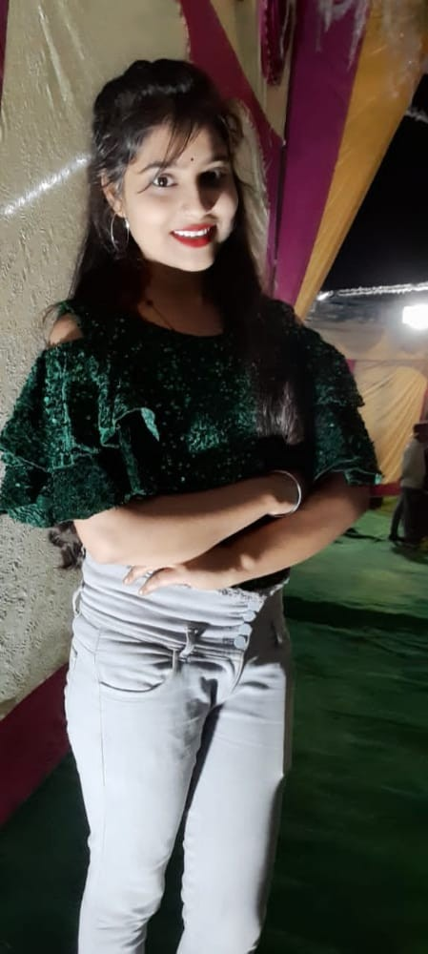

**RUCHI KUMARI**

9457436572

**Email Id:** [**ruchikushwaha6572@gmail.com**](mailto:ruchikushwaha6572@gmail.com)

**OBJECTIVE:-**

To work with an organization where can learn new skill and increase my abilities for the organization goals as well as myself.

**EDUCATION QUALIFICATION:-**

* Passed out Bachelor of art from Kanpur University.
* Passed out 12th from U.P board in 2018

Mark 70%

* Passed out 10th from U.P board in 2016

Mark 72%

**TECHINICAL SKILL:-**

* Advance diploma in computer application.

**WORK EXPERIENCE:-**

* FRESHER

**STRENGTH & HOBBIES:-**

* Hard & Smart Working
* Honest & Punctual
* Good Communication skill
* Art, Drawing, Reading books

**PERSONAL DETAILS:-**

**Father’s Name** : Mr. Ravindra kumar

**Date of Birth** : 01-08-2001

**Address**  : Vill – paharpur Lakhana (Etawah)

**Merital status** : Single

**Date ……………….** (**Ruchi )**