RESUME

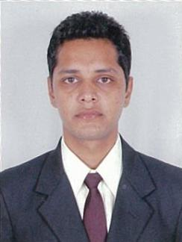
Name : BHAGESH CHOUHAN E-mail : bhageshchouhan77@gmail.com
Mobile : +918078675799

Correspondence Address:
AIMS Education Campus,
Vidhyanagar Vadtal Road,
Bakrol,
Anand – 388001.
Gujarat.
Ph-02692-239246.

__________________________________________________________________________________________

Career Objective:
To work with full diligence in a challenging environment, this provides vast opportunity and growth for mutual benefits as well as a good repute.

Area of Interest:
Front Office Department

Professional Qualification:
I have compeleted Diploma in BA-International Hospitality Administration Awarded By IGNOU & AH&LA from AIMS Hotel Management College, Anand (Gujarat).

Academic Qualification:

QUALIFICATION | YEAR | PERCENTAGE
HSC[R.B.S.E] | 2009 | 44.46%
SSC[R.B.S.E] | 2007 | 69.83%

Training Exposure: I have successfully completed 24 weeks Industrial Exposure Training in all the four major departments from
“CLUB MAHINDRA VARCA BEACH RESORT,GOA”
I have completed 06 months job training in front office department from “THE ROYAL RETREAT RESORT AND SPA,UDAIPUR,RAJASTHAN”

Working Experience:
• Worked as a FOA in Front Office Department at “FATEH GARH HOTEL”

- Frequently attended various ODC’s (Out Door Catering) at: TAJ Residency-Baroda
- TAJ Gateway-SURAT
- ITC Fortune Landmark-Ahmedabad
- Country Inn & Suites by Carlson (Ahmedabad)

Computer Skill:
Basic knowledge of computer

Hobbies
Listing Music & watching movies,Playing snooker,swimming
Personal Details:

Date of Birth : 18th Oct’1992
Marital Status : Married
Father’s name : Mr.Kanhaiyalal Chouhan
Strength : Hard working
Languages Known : English ,Hindi
Permanent Address : 10,Shanti Nagar, Roop Sagar Road,
University Road,Udaipur-313001

Reference:

Mr.Chanchlesh Parihar
(Administrative Officer)
AIMS College,Anand
Ph: 02692 239246

Declaration:
I hereby declare that all information furnished above is true to the best of my knowledge.

Date:

Place: Udaipur BHAGESH CHOUHAN

