**Curriculum Vitae**

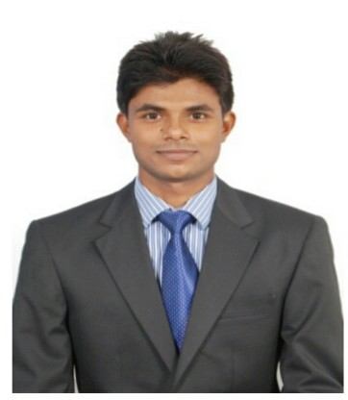**Name:** Sushil Kumar Maurya

**House No.** 2/138, Sector-H, Jankipuram,

Lucknow- 226021

**E-mail:** [sshlmaurya@gmail.com](mailto:sshlmaurya@gmail.com)

**Mobile:** +91-7838947198

**Objective:**

Seeking a position to utilize my skills and abilities in a highly esteemed and reputed organization that will give me an opportunity to groom myself in the organization. I would like to undergo different skills and gain relevant experience.

**Working Experience:**

**I worked with Broccoli Pizza and Pasta Abha Saudi Arabia for 1year 6 months (2019-2021) as a Restaurant Supervisor**

**I worked with The Manor Hotel New Delhi(Pre Opening Property) for 7 months(2018-2019) as a F&B Captain.**

**I worked with The Leela Ambience and Conventional Hotel Delhi for 11 months in Indian speciality Restaurant (2017-2018)as a GSA in F&B Service.**

**I worked with Radisson Blu MBD Hotel Noida for 2 years 3 months in Banquet, Indian speciality Restaurant (2015-2017) as a GSA in F&B service.**

**Professional Qualification:**

* Completed B.Sc 1st semester in 2012 from IHM Chennai with 72%
* Completed B.Sc 2nd semester in 2013 from IHM Chennai with 68%
* Completed B.Sc 3rd semester in 2013 from IHM Chennai with 90%
* Completed B.Sc 4th semester in 2014 from IHM Chennai with 74%
* Completed B.Sc 5th semester from IHM Chennai with 69%
* Completed B.Sc 6th semester from IHM Chennai with 72%

**Educational Qualification:**

* Passed 10+2 (CBSE Board) from SCIC, Lucknow with 54% in 2010.
* Passed 10th (CBSE Board) from Kendriya Vidyalaya, Lucknow with 53% in 2008.

**Training:**

* Done my 21 weeks training from “The Piccadilly Hotel” Lucknow.

**Extra-Curricular Activities:**

* Regular participant in college and school sports activities.

**Computer skills:**

* MS-Word, Powerpoint, MS-Excel

**Other Information:**

* Fluent in Hindi and English having a good verbal and written communication skills.
* Flexible personality, optimistic, eager to learn, hardworking.

**Personal Details:**

**Father’s Name -** Shri J.P Maurya

**Date of Birth -** 20 Feb 1993

**Gender -**  Male

**Language spoken -** English, Hindi

**Hobbies -** Playing Cricket, Listening Music

**Declaration:**

I **Sushil Kumar Maurya** hereby declare that the information given above is true to best of my knowledge and belief.

**Date:** **(SUSHIL KUMAR MAURYA)**