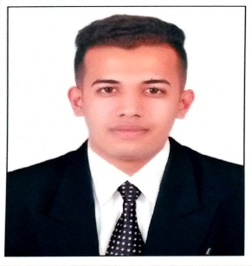

**Pranay Sanjay Singh**

**Mobile: +91-8552897285 / +91 -7666970791**

[**pranaysingh2110@gmail.com**](mailto:pranaysingh2110@gmail.com)

**Career Objective**  
Looking for an opportunity to associate with a progressive organization to utilize my skills and knowledge according to the trends and dynamically works towards the growth of the organization.  
  
**Key Skills**  
Excellent communication skill.  
Excellent interpersonal skills.  
  
**Strengths**  
Good team player.  
Pleasant personality.  
Very creative.  
Keen to learn new things.  
  
**Academic Qualification** -

|  |  |  |  |  |
| --- | --- | --- | --- | --- |
| SR  NO | NAME OF DEGREE | BOARD/UNIVERSITY | YEAR OF PASSING | PERCENTAGE  CLASS |
| 1. | BBA Hospitality & Tourism | Tilak Maharashtra Vidyapeeth, Pune | May 2019 | A Grade |
| 2. | H.S.C (SCIENCE) | State Board of Maharashtra  (Nashik) | March 2016 | 47.69% |
| 3. | S.S.C | State Board of Maharashtra  (Nashik) | March 2014 | 50% |

**Extra-Curricular Activity**

* Have done various ODC’s at 5 star properties.
* Have attended college seminars.
* Have participated in college food fest.
* Participated in Sports Competition in school.

**Work Experience**

* Have done my 45 days training in **Dew Drops Holidays Pvt. Ltd.**
* Have worked with **MAD OVER DONUTS (MOD)**, **Pune** for 12 Months.
* Have done my 5 months industrial internship training in

**BTW VISAS SERVICES PVT. LTD.**

* Have worked with **STAFFBLOOM GLOBAL SERVICES, Pune**

as operation’s executive for 3 Months.

* Have supported **Fall in Love** for the operations & product designing.

**Hobbies**

* Internet Surfing (tourist locations).
* Visiting new Places.
* Listening Music.
* Trekking and hiking.
* Photography.

**Personal Details**

Date of Birth : 26th March 1998.  
Languages known: English, Hindi and Marathi.  
Address : Flat No 5, Akanksha B Building, Bhau Patil Road,

Bopodi, Pune- 411003

**Reference** : Will be provided as and when required.

(Pranay Sanjay Singh)