***CURRICULUM -VITAE***

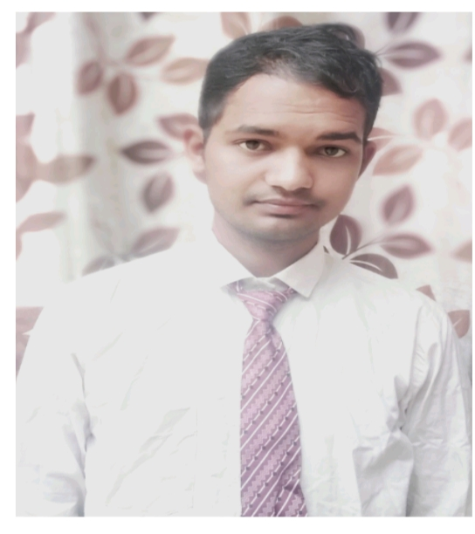

**ANUJ PANDEY**

**Diploma In Dairy Engineering**

**Mobile:+91 -7379010782**

**Mail Id : [anujdairyje9.ap@gmail.com](mailto:anujdairyje9.ap@gmail.com)**

**Skype I’d: [anujdairyje9.ap@gmail.com](mailto:anujdairyje9.ap@gmail.com)**

**Passport number: V0240931**

**Carrier Objective**

I challenging career with job satisfaction in the area of “Dairy Industry” witch modify and changes my skills so that my achievements may be helpful to obtain organizations , goals and basic objects.

**Capabilities**

Energetic, Confident, Self-motivated, Problem Solving Skill, , Quick Learner , Capable of working with accuracy under mental stress.

**Specialization**

Diploma In Dairy Engineering

**Work Experience**

Three year and six month working experience in Dairy Industry.

**Previous Employer**

**NAMSTE INDIA FOODS PVT LTD ( It's plant operations is fully automatic). Modinagar** (GAZIABAD) India. as a " Executive "in a production department from 1 June 2017to 24 July 2019 .

These company manufactures involve in manufacturing of

**Milk process, Curd, Chhach , ghee ,Butter, flavored milk etc.**

**Working field: Operation of scada , Document maintain, Batch Standardization, Handling Manpower etc.**

**Job Profile**:

.To plan activities all operation handling(processing) by scada(automation)..

To ensure effective communication during shift hand over, result presentation, and any nonconformance to standards.

Deliver the safety conformance, hygiene & housekeeping conformance to operating standards.

To ensure making of traceability report in the shift .

To ensure standardisation of batch (poch milk and curd milk)

.

To ensure the proper CIP automation and manual cleaning of the process line, Tanks and equipments.

To ensure know about of all sop

To ensure to dispatch time and per schedule.

**To ensure testing of milk and milk products , fat, snf , alcohal, acidity,**

**Maltose , rm , wash rm , protien.**

**To ensure making preparation of solution MBRT , DETERGENT SOLUTION, etc.**

**Current Employer:**

**HERITAGE FOODS LIMITED Khamanon ,Fatehgarh Sahib ,Panjab India as a Assistant manager from 25 july 2019 to Till date .**

**These unit manufacture 's involve in manufacturing of process**

**Milk, Curd , Chhach , Lassi , Yoghurt, Paneer, Ghee , ice cream**

**Job Profile**:-

To plan and execute the production difference type of processed milk ,yogurt, flavored Milk ,Butter milk ,paneer ,icecream as per sales requirement.

To ensure doing of audit in tha plant in last month with production team.

To ensure arise of fat and snf gain loss in the shift and plant daily basic.

Ensure all manufactured production meets the company standard policy and legal practice.

Responsible for all production related activities of dairy like manpower Gmp ,

Sop.

Handling of daily routine production planning and execution quality controlling.

New products development and trail at dairy plant .

Managing and controlling the technical staff.

To assist the factory manager for new product development and to implement different type SOP

Complying with ISO and HACCP and food safety team.

To assist the marketing team regarding any technical problem milk and milk products (quality issue).

Ensure proper plant and person hygiene maintain.

Responsible for Accepting and Rejecting of raw material .

Maintain of cleanliness of machine and plant area.

Coordination with store and maintenance department.

Maintain the cold storage temperature milk and milk products as per use.

Dispatching the finish goods warehouse as demand.

Conducting food safety training within department .

**Technical Qualification and educational qualification**

* Diploma In Dairy Engineering  **From JLN Polytechnic , MMB, Sitapur Uttar Pradesh India with** 75.13 % in 2017
* Intermediate science from up board (ram raj intermediate collage Patti pratapgarh Uttar Pradesh India) with 64.5% (private) in 2016
* school science from up board(sita ram intermediate collage gandhinagar ailahi Patti pratapgarh Uttar Pradesh India) with 80% in 2013.

**Personal Details**

**Name :** Mr. Anuj Pandey

**Father :** Ramesh chandra Pandey

**Sex :** Male

**Marital Status :**Unmarried

**Date of birth : 30**/10/1998

**Strength :** Ability to learn responsible hard Working

**Nationality :** Indian

Notice period : 30 days

**Address** : Vill – Mainha kalipur

Post – Lachchhipur

Distt.- Pratapgadh

Pin Code – 203304

State – U P

**Declaration**

**I here by declare that all the information mentioned about is true to my knowledge and I bear that responsibility for the above mentioned particulars .**

Date :01/02/2021

Place : Khamanon, Fatehgarh sahib , Panjab ( India)