SG Site Engineer Site Engineer

(Md. Raquib Alam)

Date:

Place:

**Declaration:**

I hereby declare that the above-mentioned information is correct up to my knowledge and

I bear the responsibility for the correctness of the above-mentioned particulars.

**Personnel info:**

Mohd. Raquib Alam

S/o: Najrool Hassan

Sex: Male

Date of Birth: 09/04/96

Nationality: INDIAN

**Communication Skills:**

English and Hindi

(Read Write and speak)

**Permanent address:**

Vill: Paroo Majhauliya Bichala Tola,

PO + PS: Paroo

Dist: Muzaffarpur

Pin Code: 843112

(BIHAR)

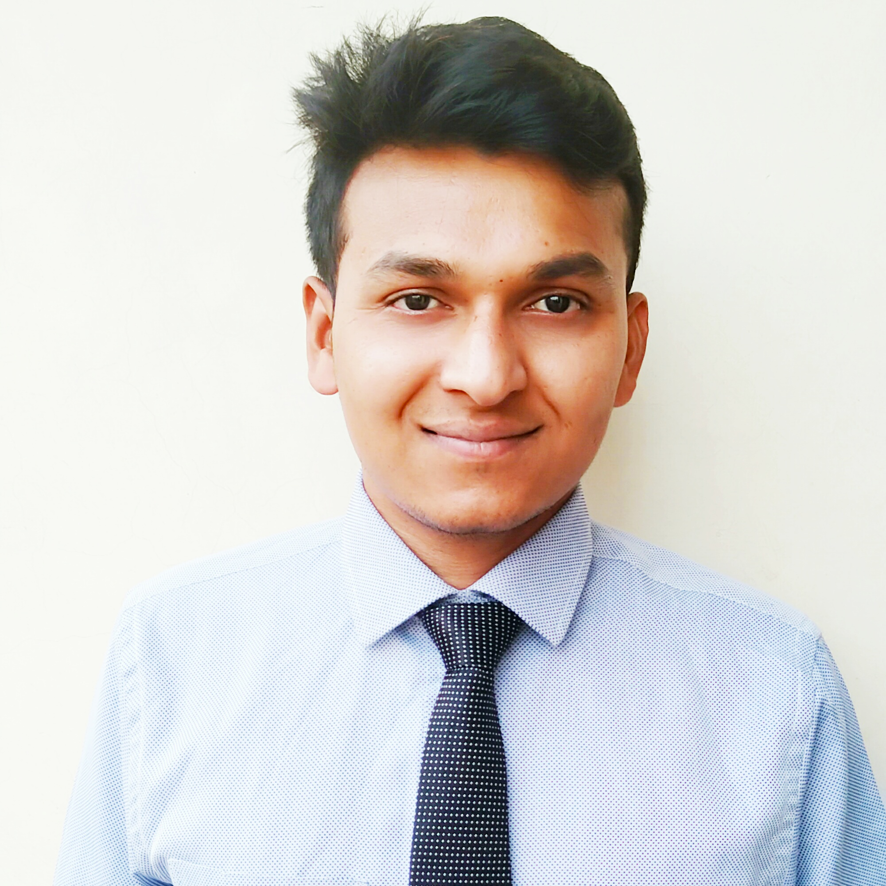

Mohd. RAQUIB ALAM

RANGPURI, MAHIPALPUR NEW DELHI - 110037

: [raquibe.alam@gmail.com](mailto:raquibe.alam@gmail.com)

: +91-8285058223

**Objective:**

* Obtain a position that will give me the opportunity to apply my retail sales experience to a growing industry. To obtain employment with a company that promotes quality products and provide me with opportunities to meet and exceed assigned sales goals.

**Educational Qualification:**

* Pursuing Graduation from Delhi University.
* **HSC** (PCM) from BSEB, PATNA
* **SSC** from BSEB, PATNA

**Experience:**

* Currently working in UNIQLO as a Retail Associate from 19august 2019 to till now.
* 1.2 years of experience as a Sales Executive in FUTURE GROUP

**Achievements:**

* Digital marketing from Google
* Six months DCA (fundamental of computers, MS-office,

MS-Excel & internet) From Rashtriya Sarv Saksharta Abhiyan.

**Computer Skills:**

* Basic knowledge of computer application and internet.
* **Operating System**: Windows 7 &10,
* **Microsoft Office.**

**Interests and Hobbies:**

* Playing Cricket, Listening music and singing

**RESUME**