APOORVA JAGTAP

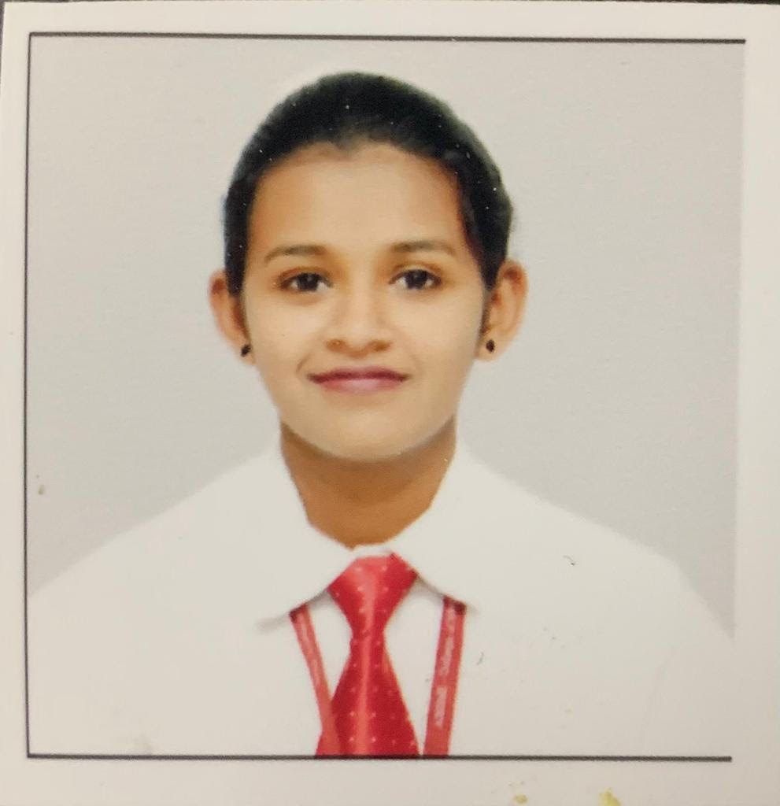

**PERSONAL DETAILS**

Date of Birth : Dec 25th 1996

Nationality : Indian

Current Location : Pune, India

Marital Status : : Single

Contact No : +91 9545983893

Email Id : [apoo.k.j@gmail.com](mailto:apoo.k.j@gmail.com)

# PROFESSIONAL OBJECTIVE

# 

Seeking the position where my skills of customer service, management and strategic planning would be utilized. To bring in my skills of handling employees and bringing out the best in them leading to best customer experiences.

# ACADEMIC QUALIFICATION

**Bachelor's in Science- Hospitality Studies**,

affiliated to Savitribai Phule Pune University

**Board of Higher Secondary Education** (class XII)

MCVC from HSC Board secured 65%

**Board of Secondary Education (**class X)

From SSC Board secured 72%

# PROFESSIONAL EXPERIENCE

## **iVenus - Apple Authorised Reseller, Kothrud, Pune (April 2021 to Present)**

Profile: Sales Advisor

* Handling customer queries.
* Responsible for monthly sales target achievement.
* Making sure all the accessories are in place.
* Taking care of delivery items in the store.
* Lead Generation.

**Nyasa- Apple Premium Reseller Store, Pune (April 2018 to April 2021)**

Profile: Sales Advisor

* Handling customer queries.
* Responsible for monthly sales target achievement.
* Making sure all the accessories are in place.
* Taking care of delivery items in the store.
* Follow up with customers after sale.
* Lead Generation.

**Domino’s Pizza, Pune (May 2017 to March 2018)**

**Vivanta by Taj-Blue Diamond, Pune (Nov 2016 to April 2017)**

**Domino’s Pizza, Pune (October 2015 to November 2016)**

**SKILLS**

* Fluency in English both written and speaking.
* Creativity.
* Flexibility and adaptability.
* Instant decision making.
* Punctuality.

**HOBBIES AND INTERESTS**

* Socializing- Volunteer Work.
* Riding bikes.
* Movies and Listening Music.
* Culture exchange.
* Travelling.
* Team sports.

**ACHIEVEMENT**

* Top sales achiever for Nyasa in Maharashtra state for month of April 2019
* Received best service person award at Domino’s Pizza.
* Received best Monthly service guru award 4 times while working with Dominos.
* Received highest monthly sales achiever award at Dominos.
* State level player – Taekwondo (3rd Position)
* District level player – Taekwondo (2nd Position)
* Interclass player – Skating (Winner)
* Interschool player – Skating (Winner)

Thank You!

Apoorva Jagtap.