Shubham Dwivedi  PROFESSIONAL SUMMARY  Seeking an entry level position to begin my career  In a high level Professional environment. Also to make use of my  Interpersonal skill skill to achieve goals of a company that focused on customer satisfaction customer experience.  EDUCATIONand  International Institute of Hotel Management, Location — Pune 20XX - MONTH 20XX  Pursuing Bachelor of Arts in Tourism Studies (IGNOU)  Advanced Diploma in Hospitality Studies from Yashwantrao Chavan Maharashtra Open University.  3 years advance program in international hospitality administration (I.H.A)  School Name, Location — 12th Standard  MONTH 20XX - MONTH 20XX  Completed your board name with **% 50  National institute of Open school  School Name, Location — 10th Standard  MONTH 20XX - MONTH 20XX  Completed your board name with **% 50  National institute of Open school  EXPERIENCE  Hotel Name, Location — Industrial Trainee  MONTH 20XX –  I could not do my internship due to Covid-19. Any part-time job, Location — Position  MONTH 20XX – PRESENT  Part time job like we ODC in different hotels  Like Marriott, Rizt carlton, Westin, etc. | 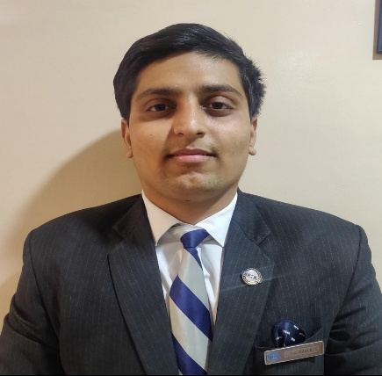  CONTACT INFORMATION  Air force campus Viman nagar pune  (+91) 7620441983  Shubhamdwivedi0223@gmail.com  https://www.linkedin.com/in/shubham-dwivedi-443482193  SKILLS  1.Creativty,teamwork , Mentorship  Ability to Skilfully Multitasking  Multi-tasking Abilities .  AWARDS/CERTIFICATIONS  - Foodfest certification  - National certificate in cricket  - Badminton certification In Reginal in kvs  LANGUAGES  Hindi ,English

