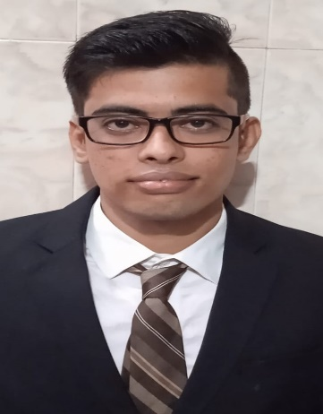  Date of Birth : 16/10/1998  CONTACT:   atul70624@gmail.com   7666720351  Address: A/4, Aliyar Singh Chawl, Shivaji nagar, Kurar Village, Malad east, Mumbai – 400 097, Maharashtra, India.  KEY SKILLS:  Communication  Collaboration  Flexibility  LANGUAGES:  English  Hindi  Marathi  Hobbies/ interest  Social Working  Playing Cricket  Book Reading  Keeping Knowledge regarding Politics | ATUL SINGH  CAREESR OBJECTIVE:  To secure a challenging position in a reputable organization to expand my knowledge and skills.  PROFILE SUMMARY:  A professional with a selling experience.  Client servicing and Client relationships acting as an intermediary.  SUMMER INTERNSHIP PROGRAM: MMS – MARKETING.  COMPANY’S NAME: 1) S.M. Enterprises. (8th June – 7TH August 2021)  2) iFortis Corporate. (1st June – 15th July 2021)  PROJECT TITLE: Analysis of Sales Promotion in RMC Industry.  ROLE AND IMPLEMENTATIONS: 1) Marketing and Sales Intern.  2) Promoting the Product.  ACADEMIC CREDENTIALS:  Program Institute/University Year % / CGPA  MMS Marketing Durgadevi Saraf Institute of Management Studies, Malad West. (MUMBAI UNIVERSITY) Pursuing -  BMS Patkar – Varde College, Goregaon West. (MUMBAI UNIVERSITY) 2020 6.2 CGPA (59%)  HCS Thakur College of Science and Commerce, Kandivali East. (State Board of Maharashtra) 2017 76%  SSC St. Francis High School, Malad East. (State Board of Maharashtra) 2015 76.60%  cERTIFICATIONS:  Got Trophy, Medal and Certificate in Thakur college by Rajpoot Sangh for gaining a good marks in Accounts in HSC with the hands of IAS Deependra Kushwah sir.  PROJECTS:  SIP project (FY-MMS)  Black Book project (TY-BMS)  eXTRA CURRICULAR ACTIVITIES:  As a social worker created a charity in kurar village, malad east which is named as Friend’s Group who works for the betterment of the society. We provide foods, clothes and other necessary items to needy. We helps in a different way.  EXPERIENCE:  Name of the Company: Jay Cable Network, malad east.  Designation: Collection Executive and Sales Coordinator.

