CURRICULUM VITAE

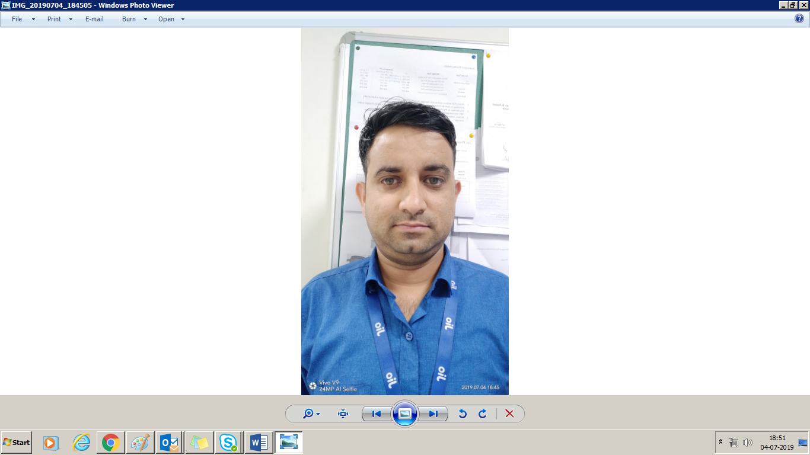

PRESENT ADDRESS

B140, SECTOR 20

NOIDA

PIN: - 201301

PH :- 9015748796

LOVELY CHOUDHARY LBALIHAR683@GMAIL.COM

CAREER OBJECTIVE

Looking for a challenging job where I can contribute my academic qualification and personal skills towards the success of the organization along with my professional career, a job that will earn me satisfaction and enable me to learn more and more in life,

# PROFESSIONAL QUALIFICATION

* 3 Years DIPLOMA in “ELECTRONICS AND COMMUNICATION

ENGINEERING” from Govt. Polytechnic Kangra (HIMACHAL PARDESH)

PREVIOUS JOB PROFILE: -

From AUG/ 2008 to Oct/2011: With NOKIA at Chandigarh sector 27B.

• Conducted repairs on cell phones and do their respective software

implement

• Referred to cell phone manuals to ensure the repairs done to the units are accurate.

• Analyzed the problems of cell phone units before proceeding with the repairs.

PREVIOUS JOB PROFILE: -

From Oct/2011 to 2nd April /2015: Worked in Samsung India Electronics Pvt. Ltd (Impex pvt ltd). As a Service Engineer

• We do IQC before proceeding with the repairs.

• Conducted repairs (Hardware) on cell phones, Galaxy Tabs and do their respective software implement.

• Repaired action on SMD components.

•    Excellent in Microsoft office outlooks

PREVIOUS JOB PROFILE: -

From 1st May 2015 to 30th December 2017 Worked in Samsung Service centre (Noida) As a Service Engineer

• We do IQC before proceeding with the repairs.

• Conducted repairs (Hardware) on smart phones

• We do OQC after repaired.

PREVIOUS JOB PROFILE: -

From 2nd January 2018 to 30 December 2019 Worked in Jio Service Centre (Noida) As Service Engineer.

• Conducted repairs (Hardware) on smart phones

• We do OQC after repair.

•    Excellent in Microsoft office Excel worksheet

PRESENT JOB PROFILE: -

From January 2020 to till date Working in FUTURE WORLD RETAIL INDIA as iOS Engineer.

* Conduct repairs (Hardware) on all Apple Devices except Mac.
* Key responsibilities to achieve all KPI.
* Maintaining Inventory
* Documenting Repairs and Maintenance.
* Providing Technical support to New Joinee.

EXTRA CO- CURRICULAR ACTIVITIES

   • Project Work in Electronic letter box machine.

STRENGTHS

• Ability to live and work in a group excellently.

# PERSONAL DETAILS

Father’s Name : Mr. Arjun Kumar

Date of Birth : 22 JULY 1989

Marital Status : Married

Gender : Male

Languages Known : Hindi, English,

Nationality : Indian

Place: - Noida (LOVELY CHOUDHARY)