**CURRICULUM VIATE**

**PRADEEP CHANDELA**

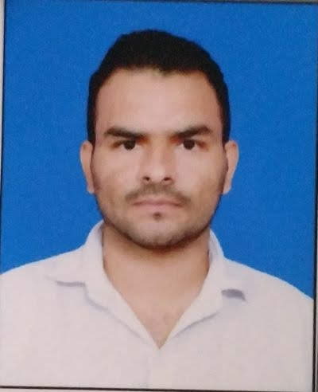

Address-H.N.-30J, Gali No  5/3

Shakti Vihar, Namberdar Colony

Mithapur, Badarpur

New Delhi - 110044

Mob- +91 9136661212

Email  prachandela@gmail.com

|  |
| --- |
| **OBJECTIVE** |

To build a prosperous and successful carrier by performing with virtue, integrity and

undertaking can Important responsibility in or to assure to the progress of the

Organization with the help of the organization with the help of Management.

|  |
| --- |
| **SUMMARY** |

* Over Nine years of experience working in diverse retail sales.
* Proven track record of exceeding aggressive sales quotas.
* Hardworking, energetic, and reliable; recognized for assuming additional responsibilities.
* Develop and execute territory and specific account sales plan.
* Excellent team player, as well as maintain good relations with channel partners.
* Delivering beyond expectations through professionalism, market knowledge and sales target.
* Strong prospecting and negotiations skills.

|  |
| --- |
| **EXPERIENCE** |

Designation : **Senior Sales Executive**

Company : **Apple Premium Reseller**

Company Profile : Retail

Duration : 09th August 2021 to Till Date

Designation : **Sr.** **ISC**

Company : **APPLE** (Channel Play Ltd.)

Company Profile : Retail

Duration : 21st Oct.2013 to 27th March 2019

Continue Page-2

Page-2

Designation : **Sale Executive**

Company : **HTC** (Manpower Solutions India Pvt. Ltd.)

Company Profile : Retail

Duration : 07st Oct.2011 to 20th Oct. 2013

|  |
| --- |
| **KEY RESPONSIBILITIES** |

* Maintain inventory of overall stores as per the targets to be achieved.
* Market Research and analysis for better output results.
* Working on the various activities to improve the sales of stores under me.
* Giving responsibilities to the team members as per their strengths and guidelines to improve on their Weaknesses.
* Handling a team and manage inventory and sales of a region assigned.
* Apple Business by building a strong influential, collaborative business relationship with the reseller and sales team.

|  |
| --- |
| **EDUCATIONAL QUALIFICATION** |

* Graduate from **Delhi University.**
* Intermediate from **CBSE Board.**
* Matriculation from **CBSE Board.**

|  |
| --- |
| **ADDITIONAL QUALIFICATION** |

* Diploma in Graphics from Delhi Institute of Computer Science, Lajpat Nagar, New Delhi**.**
* Advance Knowledge of Computer.
* Excellent Typing Speed in English. (40 words/minute)
* Advance Knowledge of Internet.

|  |
| --- |
| **PERSONAL DETAILS** |

**Father's Name *:*** Sh. Saman Singh

**D.O.B *:*** 03th Mar. 1991

**Nationality *:*** Indian

**Languages known *:*** English & Hindi

**Marital status *:*** Married

**Hobbies :** Reading News and Articles, Listening to Music

Date Place

**PRADEEP CHANDELA**