**RESUME**

MOHAMMED BILAL QURESHI 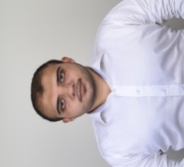

Flat No.107, B-wing, Bldg. No.13,

Amrut Nagar Jogeshwari West

Mumbai-400102.

Email: [qureshib7@gmail.com](mailto:qureshib7@gmail.com)

Mob: +91 9167352381

PERSONAL DETAILS:

* Father Name : Mohammed Yasin Qureshi
* Date of Birth : 28/11/1996
* Gender : Male
* Nationality : Indian
* Marital Status : Single
* Religion : Islam
* Languages Known : English , Hindi & Urdu
* Hobbies : Listening Music, Photography &

Modification of cars & Bikes on computer

**EDUCATIONAL QUALIFICATION:**

* S.S.C. Passed from NIOS Board
* H.S.C. Passed from Maharashtra Board
* Pursuing B.COM from University of Mumbai (Distance)

**ADDITIONAL QUALIFICATION:**

* Computer literate
* ICIT Certified office professional - Module I
* ICIT Certified office professional - Module III
* Personality Development Course from APTECH Institute
* Mind Your Languages English Course from APTECH Institute
* Photography
* Driving Cars and Riding Bikes

**WORK EXPERIENCE:**

**Counter Salesman**

* Worked Part time for a period of two months during summer holidays of 2018 & 2019 in Titan Eye Plus as a counter sales person.

**Photographer**

* March – May 2019 : Worked as a photographer with Election Commission of India during Election.

Place: Mumbai

Date: June 18, 2019

*Mohammed Bilal Qureshi*