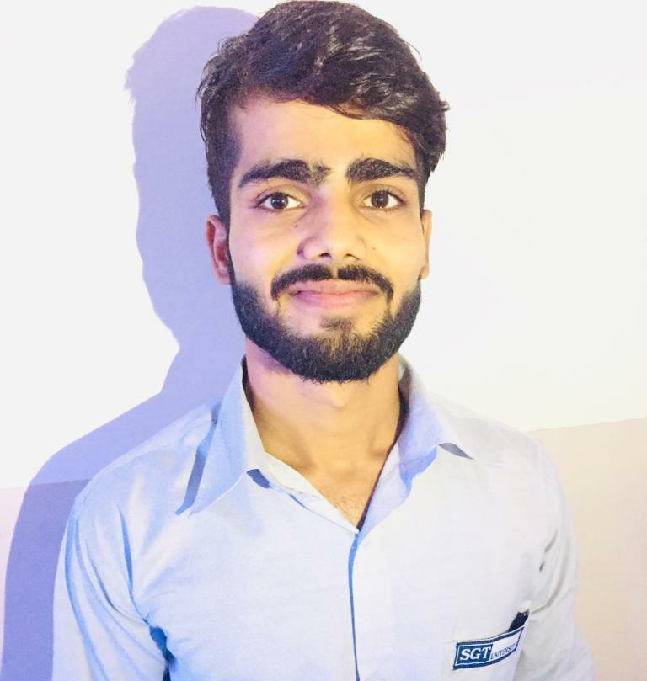

MOHIT KUMAR DWIVEDI

**Address-** A-29, Shiv Ram Park Phase-2, Nangloi, West Delhi

**Contact no-** 7210043788

**Email-** [mohit.eng@yahoo.com](mailto:mohit.eng@yahoo.com)

# Carrier Objective

To work on a challenging job profile which provides an opportunity to enhance my personal and professional skill and knowledge, this could provide me an insight into new aspects so that it would be helpful for my career.

# EDUCATIONAL QUALIFICATION

| **Year** | **Course** | **Institute Name** | **University/Board** |
| --- | --- | --- | --- |
| **2018-2021** | **Bachelor of computer applications** | Shree guru Gobind Singh tricentenary university | University grants  commission |
| **2018** | **Senior**  **Secondary Education** | Government Sarvodaya Bal Vidyalaya | CBSE |
| **2016** | **Secondary Education** | Daulat ram public school | CBSE |

**PROJECT & TRAINING-**

* Attended training on AI in all soft solution for 2 months.
* Attended workshops on ethical hacking/AI.
* Attended 24 hour’s training under connect with work program of Barclays.
* Attended various national and international workshops in various sectors.

# ACHIEVEMENT-

* Got 1st prize in college tech fest.(2018 & 2019).

# PROFESSIONAL SKILLS-

* Communication Skill
* Leadership
* Team Management
* Adaptability
* Negotiation
* Programming in (C/C++/python)
* Web designing
* Microsoft office

# CO-CURRICULAR ACTIVITIES-

* Participated in tech fest at college level.
* Participated in college sports meet from 2018-2019.

# INTEREST AND HOBBIES-

* Travelling
* Playing Sports
* Exploring new techs

(MOHIT KUMAR DWIVEDI)